### Miniature House #4 - A Cape Cod with a Columned Porch

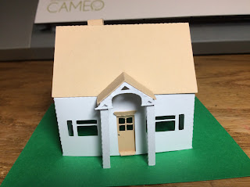

This model was a little difficult to construct. The bottom edge of the roof line of the porch and the main roof are even and there isn't a tab to connect them. There is a tab to connect the roof to the house but that really doesn't help (see picture below for placement). Apply a little glue to the edge of the porch roof and hold it there until the porch roof is dry and attached. The columns are angled at the top. Be aware of the direction that they are placed. The columns should be angled opposite of one another. There is a tab on the columns to be glued to the base. I recommend gluing the column to the base first and then to the roof.  
  
I used card stock.

